**Open Dataset of Electromagnetic Spectrum Data**

**For Radio Map/Channel Map/RSSI Map**

**Note: This work is done by Nanjing University of Aeronautics and Astronautics. Require the latest dataset please contact zhuqiuming@nuaa.edu.cn.**

1. **Received signal strength under urban scenario (RT-based method)**
   1. **Simulation setup**

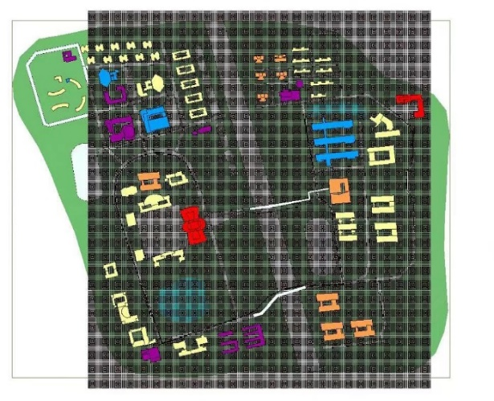

Fig. 1. Simulation scenario and trajectories. Fig. 2. Meshed map.

**Table 1 Scenario parameters**

|  |  |  |  |
| --- | --- | --- | --- |
| Radiation sources  (Transmit power: 0dBm  Frequency: 2.45GHz) | Pedestrians | | 4 |
| Vehicles | | 2 |
| Base station  (Directional antenna) | | 1 |
| Mobile radio | | 1 |
| Velocity  (Along the road) | Pedestrians | | 1m/s |
| Vehicles | | 4-5m/s |
| Base station. | | 0m/s |
| Mobile radio | | 3-4m/s |
| Scenario size | 1.25km*1.25km | | |
| Simulation Duration | 5min (300s) | | |
| Update time | 1s | | |
| Grid resolution | 5m*5m | | |
| Height | Dynamic data | 2m, 80m | |
| Static data (t=100s) | 2m,10m,20m,30m,  40m,50m,80m | |
| Data size | 250*250*300 | | |

* 1. **Data Files**

The RT-based simulation data files include two scenarios, dynamic scenario (radiation sources are moving) data at the height of 2m and 80m, and static scenario (radiation sources are fixed) data at the height of 2m, 10m, 20m, 30m, 40m, 50m, 80m.

The received signal strength data in the dynamic scenario is a .mat file in the format of a 250*250*300 tensor, where x, y represents the spatial grid dimension, z represents the time dimension, and the numerical value represents the signal strength in dBm. The file size at the height of 2m is 113MB, and the one at the height of 80m is 131MB.

The received signal strength data in the static scenario is a .mat file in the format of a 250*250 matrix, where *x*, *y* represents the spatial grid dimension, and the numerical value represents the signal strength in dBm. The data file sizes for the heights of 10m, 20m, 30m, 40m, and 50m are 363KB, 385KB, 400KB, 406KB, and 405KB, respectively.

* 1. **Dataset visualizations**
* **Dynamic scenario**

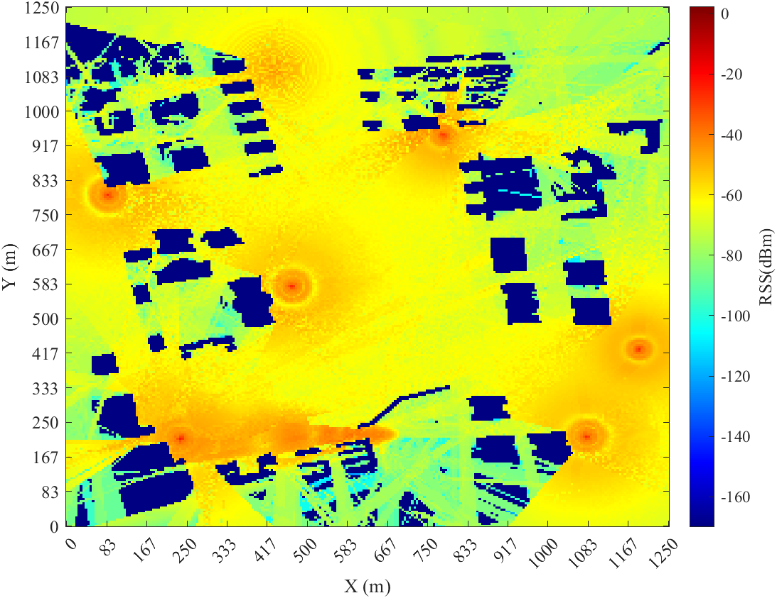 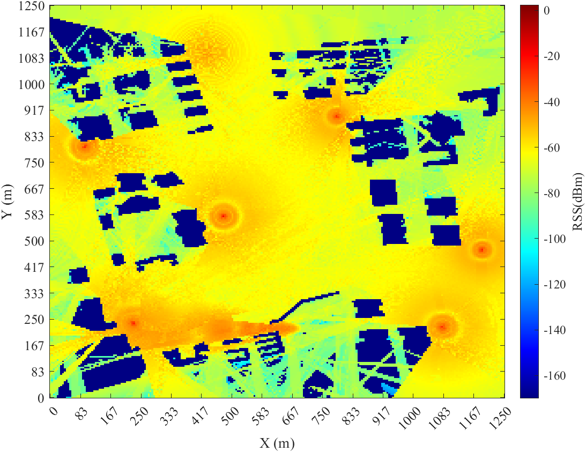

Fig. 3a. height = 2m, time = 1s. Fig. 3b. height = 2m, time = 10s.

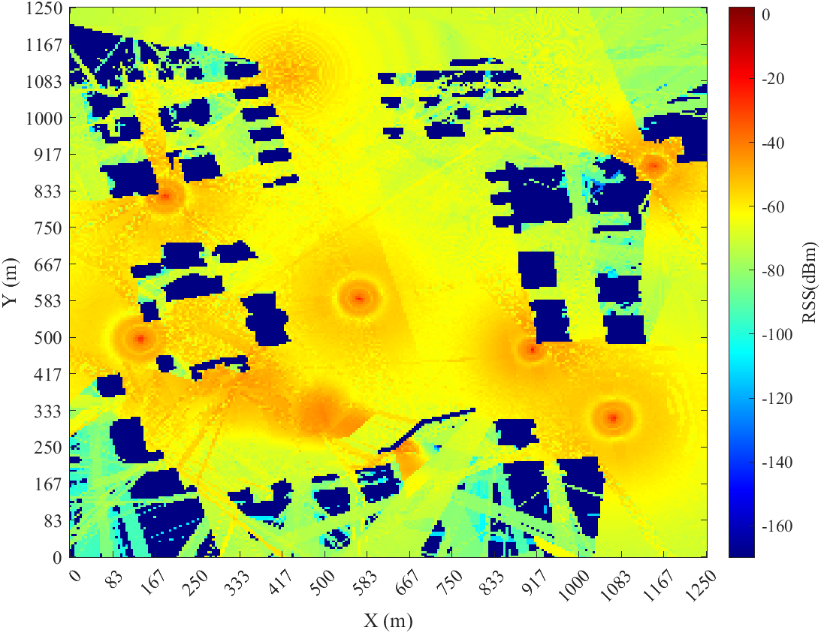 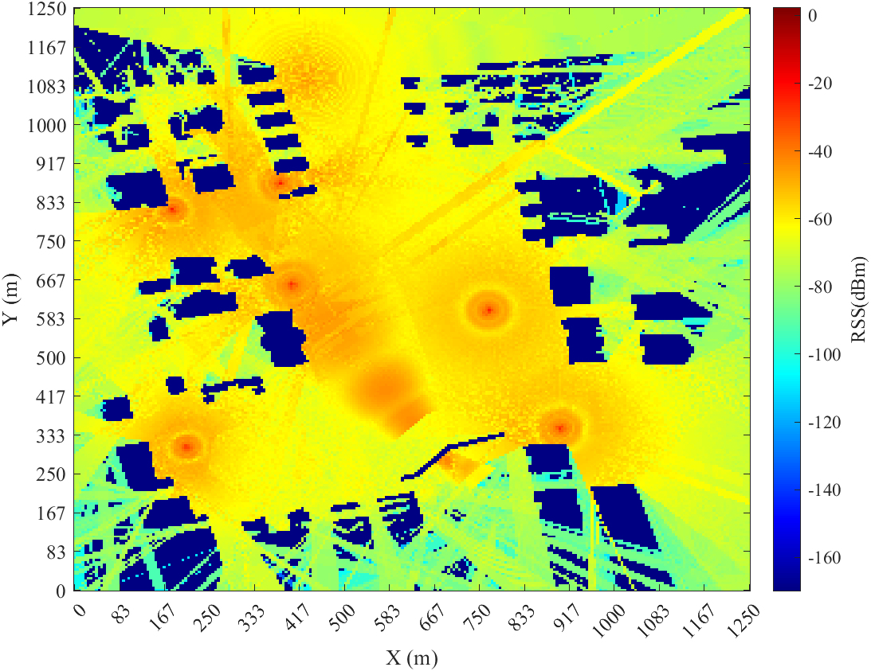

Fig. 3c height = 2m, time = 100s. Fig. 3d height = 2m, time = 300s.

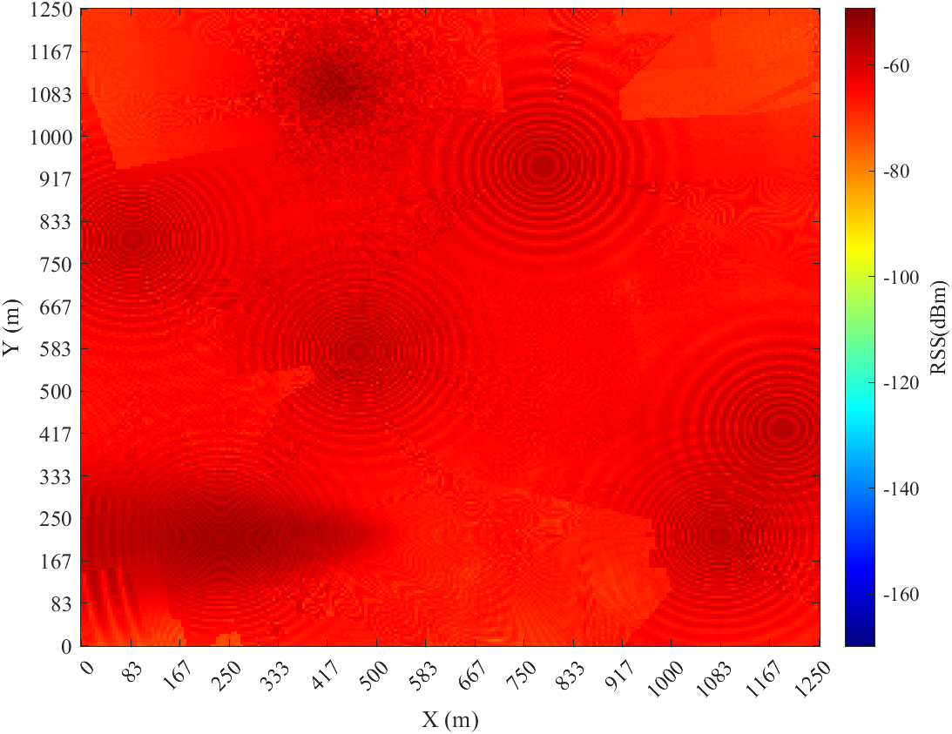 

Fig. 4a height = 80m, time = 1s. Fig. 4b height = 80m, time = 10s.

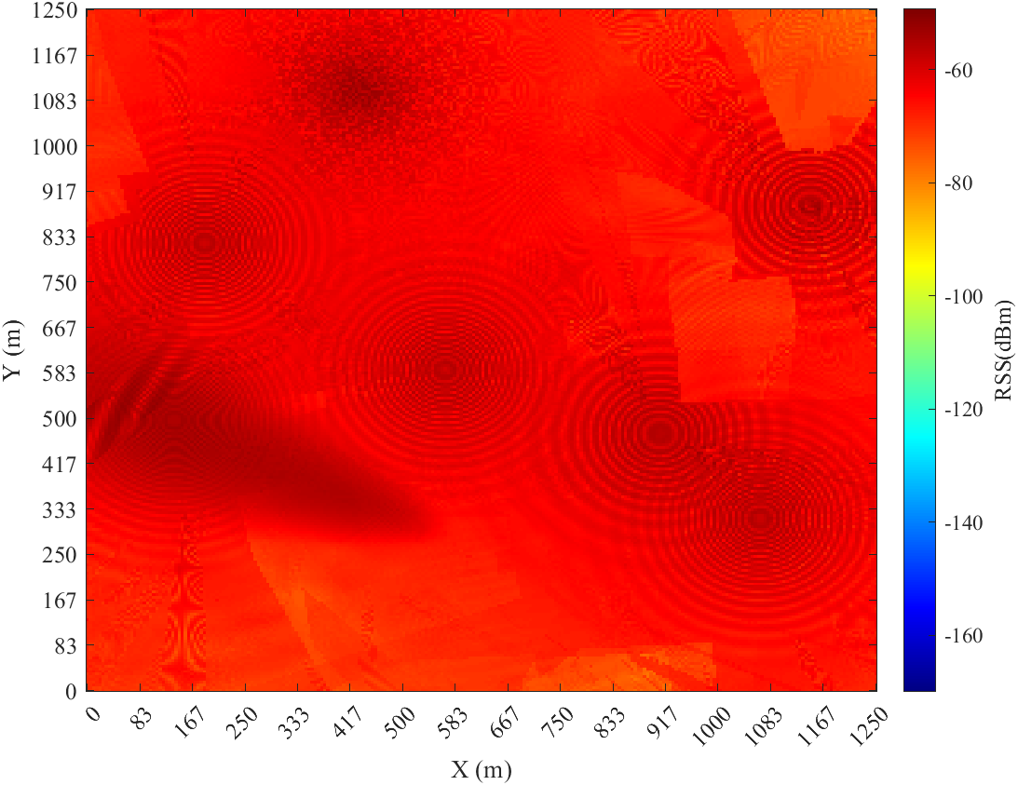 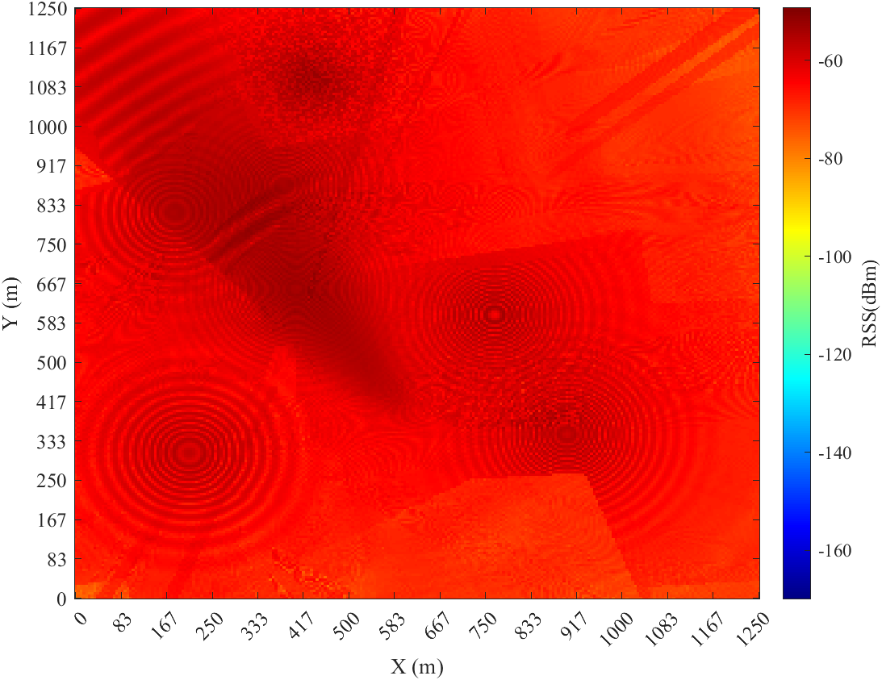

Fig. 4c height = 80m, time = 100s. Fig. 4d height = 80m, time = 300s.

* **Static scenario (t = 100s)**

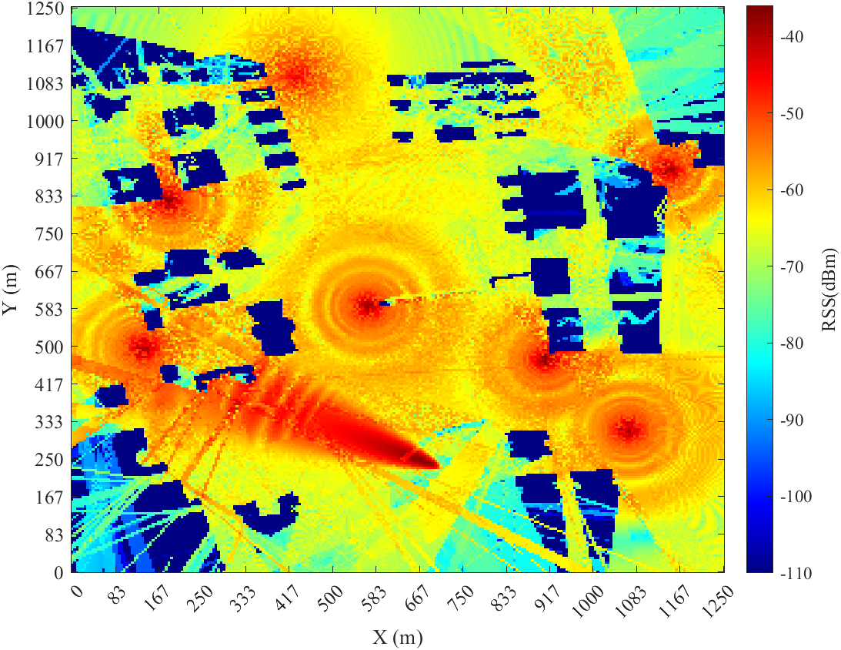 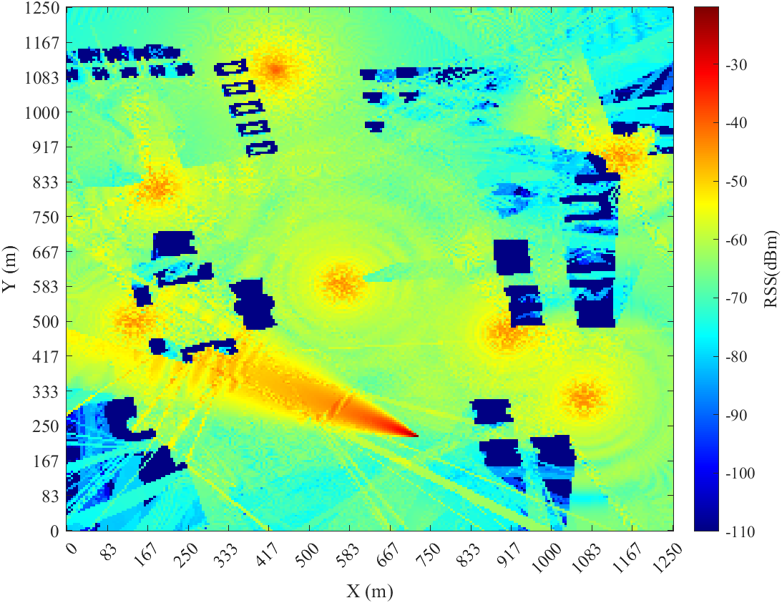

Fig. 5a height = 10m, time = 100s. Fig. 5b height = 20m, time = 100s.

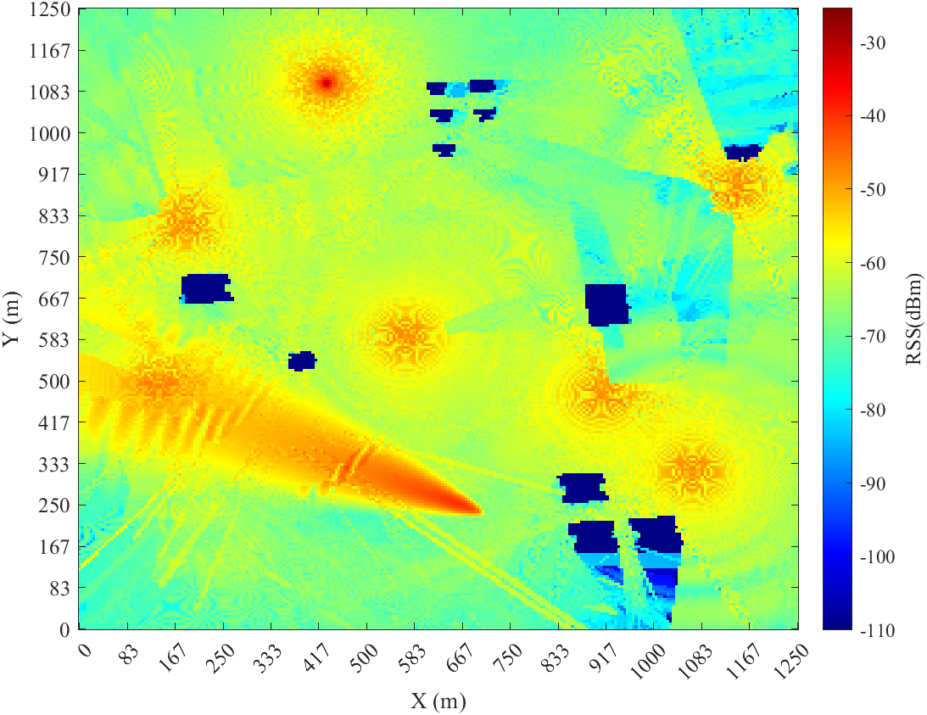 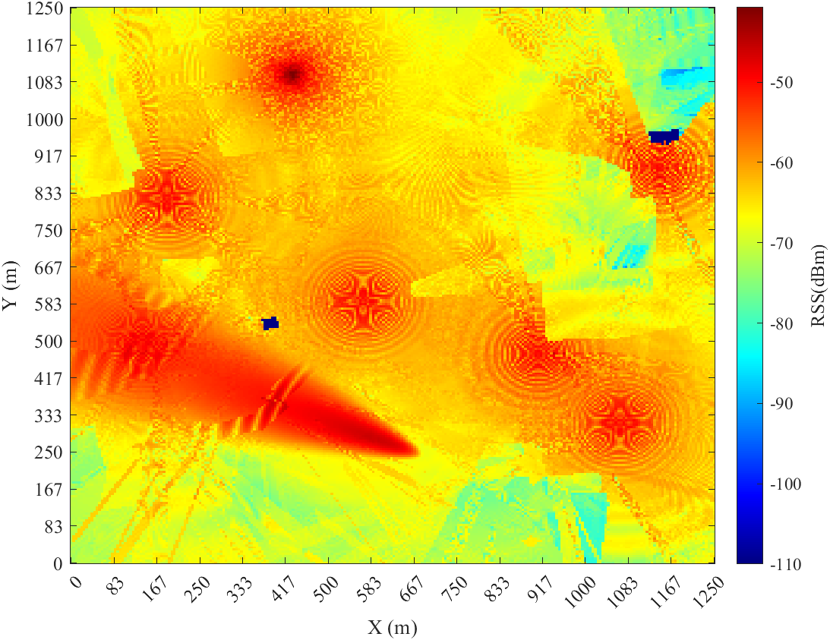

Fig. 5c height = 30m, time = 100s. Fig. 5d height = 40m, time = 100s.

* 1. **Recommended references**

1. J. Wang, Q. Zhu, Z. Lin, J. Chen, G. Ding, Q. Wu, G. Gu, Q. Gao. “Sparse Bayesian Learning-Based Hierarchical Construction for 3D Radio Environment Maps Incorporating Channel Shadowing,” *IEEE Transactions on Wireless Communications*, early access, 2024, doi: 10.1109/TWC.2024.3416447.
2. Y. Zhao, Q. Zhu, Z. Lin, L. Guo, Q. Wu, J. Wang, W. Zhong. “Temporal prediction for spectrum environment maps with moving radiation sources,” *IET Communications*, vol. 17, no. 5, pp. 538–548, 2023.
3. Q. Gao, Q. Zhu, Z. Lin, Y. Zhao, J. Wang, W. Zhong, Y. Huang, Q. Wu. “Spatial Sensor Layout Optimization for Radio Environment Map Construction,” 2024 IEEE Globecom Workshops, 2024, for publication
4. **Measured Signal Strength Dataset under Campus Scenario** 
   1. **Measurement setup**

 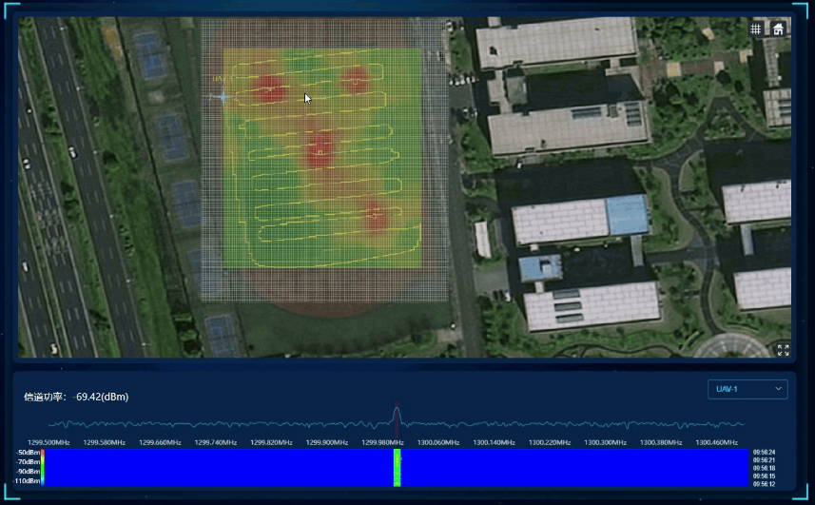

Fig.1 Four-radiation-source scenario. Fig. 2 Sampling path and meshed area.

Table 1 Measurement parameters

|  |  |  |  |  |  |  |
| --- | --- | --- | --- | --- | --- | --- |
|  | Parameter value | | | | | |
|  | Signal generators | Height  (m) | Horizontal(m) | Vertical(m) | Power  (dBm) |
| Radiation sources  (Omni- antenna 1.3GHz  ) | 1 | Tektronic TSG 4106A | 0.6 | 28 | 90 | 10 |
| 2 | Ceyear 1435B | 0.6 | 68 | 90 | 10 |
| 3 | ROGIL DSG821 | 0.6 | 50 | 58 | 10 |
| 4 | Ceyear 1465B | 0.6 | 78 | 25 | 10 |
| Velocity | 1m/s | | | | | |
| Duration | 5s | | | | | |
| ROI size | 97m*117m | | | | | |
| Grid size | 1m*1m | | | | | |
| Sampling height | 1m | | | | | |
| Sampling interval | 1m*1m | | | | | |
| Sampled data amount | 940 grids（t=1s），968 grids（t=2s），922 grids（t=3s），  940 grids（t=4s），907 grids（t=5s）， | | | | | |
| Constructed REM size | 117 grids * 97 grids * 5 slices | | | | | |

* 1. **Dataset format**

The signal strength data is described by a matrix of 117*97 in a .mat file, where *x* and *y* represent the spatial grid index, and the value represents the signal strength in dBm. The size of each file is 7KB. The measured data along the sampling trajectory is stored in the corresponding grids, while zero is set to the other grids.

The constructed REM data based on measured data is described by a 117*97*5 tensor, where *x*, *y* represents the spatial grid index, *z* represents the time index, and the value represents the signal strength in dBm. The size of each file is 403KB.

* 1. **Dataset visualization**

**2.3.1 Raw data visualization**



Fig.3. Raw received signal strength (height = 1 m, time = 1-5 s)

**2.3.2 REM visualization**



Fig.4. Constructed REM data (height = 1 m, time = 1-5 s)

* 1. **Recommended references**

1. Q. Zhu et al., "DEMO Abstract: An UAV-based 3D Spectrum Real-time Mapping System," 2022 IEEE Conference on Computer Communications Workshops (INFOCOM WKSHPS), New York, NY, USA, 2022, pp. 1-2.
2. Y. Zhao, et al. “Temporal prediction for spectrum environment maps with moving radiation sources,” IET Communications, vol. 17, no. 5, pp. 538–548, 2023.
3. Q. Gao, et al. “Spatial Sensor Layout Optimization for Radio Environment Map Construction,” 2024 IEEE Globecom Workshops (GC Wkshps), 2024.